# Introduce

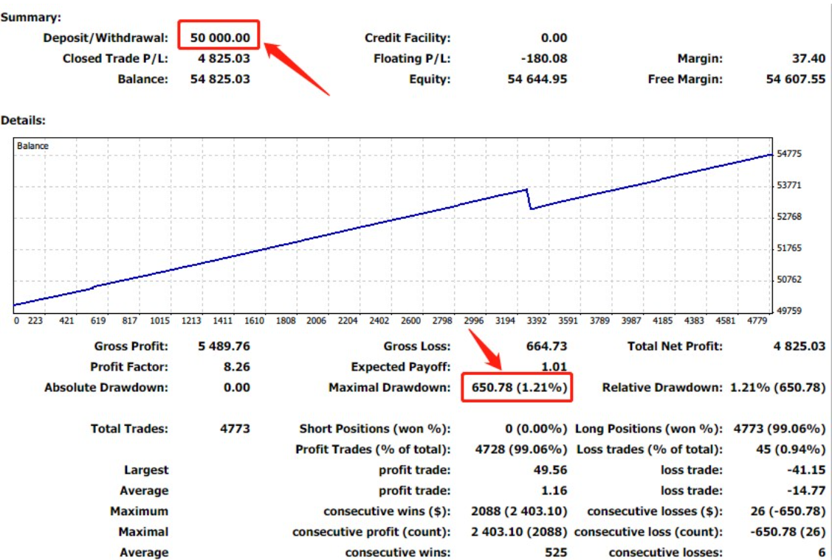

We are the first person to challenge the Guinness World Record in finance with a 100% success rate of 10,000 transactions in 100 days.Record: From May 2, 2022 to September 15, 2022, there were a total of 99 trading days. The gold variety stopped at 47 trading days, with a total of 4068 transactions and blew up.The crude oil variety had a total of 10,005 transactions with a 100% success rate, completing the challenge of "100 days, 10,000 transactions, 100% success rate."

# Description of document purpose:

**ebcgroup4setup_2.zip:**MT4 software installation package, if your computer does not yet need MT4 software, first unzip the file -> Install software.

**Batch cancellation.ex4:** indicates the batch cancellation function.

**Invincible EA Demo Free.ex4:** A free trial version of the automatic bulk ordering feature.

**If there is no reply for a long time, you can leave a message or a private message in the following way, which will patiently answer for you:**

[**z1930299709@outlook.com**](mailto:z1930299709@outlook.com)

**Alternatively, you can view more works or contact authors in the following ways:**

**Tiktok:**[**https://www.tiktok.com/@free_trial_mt4_ea?is_from_webapp=1&sender_device=pc**](https://www.tiktok.com/@free_trial_mt4_ea?is_from_webapp=1&sender_device=pc)

**YouTube:**[**https://www.youtube.com/@zggg-rw3bq**](https://www.youtube.com/@zggg-rw3bq)

**X:**[**https://x.com/z_ggg82138**](https://x.com/z_ggg82138)

# instructions

## Install the MT4 software

**Decompress ebcgroup4setup 2.zip Double-click to install the software**

## Place the two script files in the specified directory

**Batch cancellation.ex4 and Invincible EA Demo Free.ex4 will be downloaded**

**Put it in this path down here**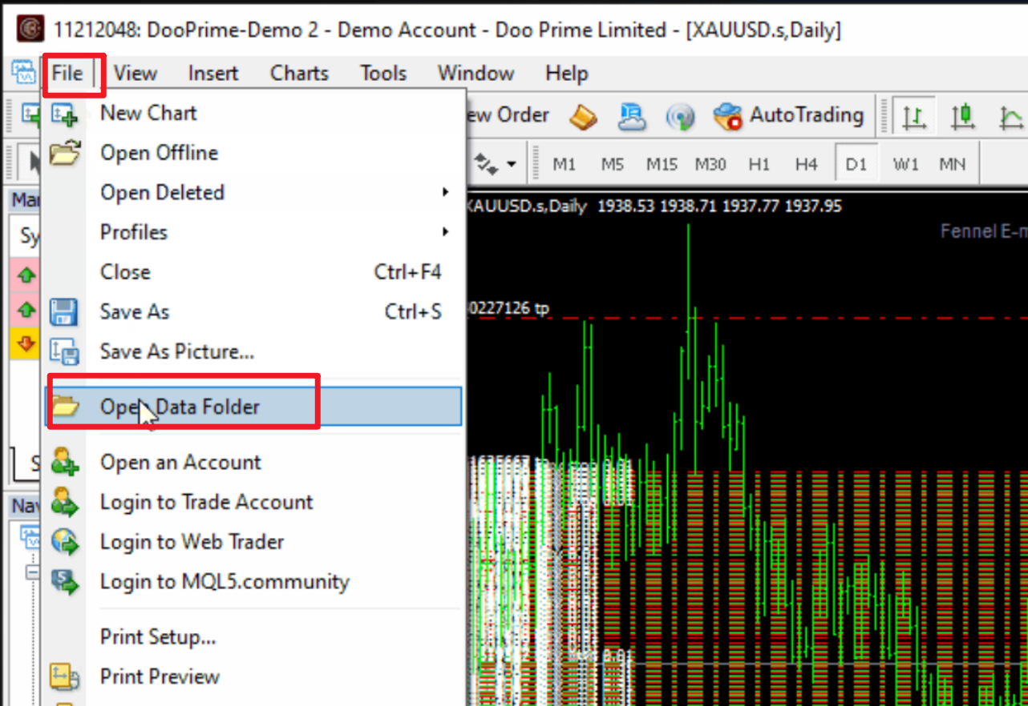

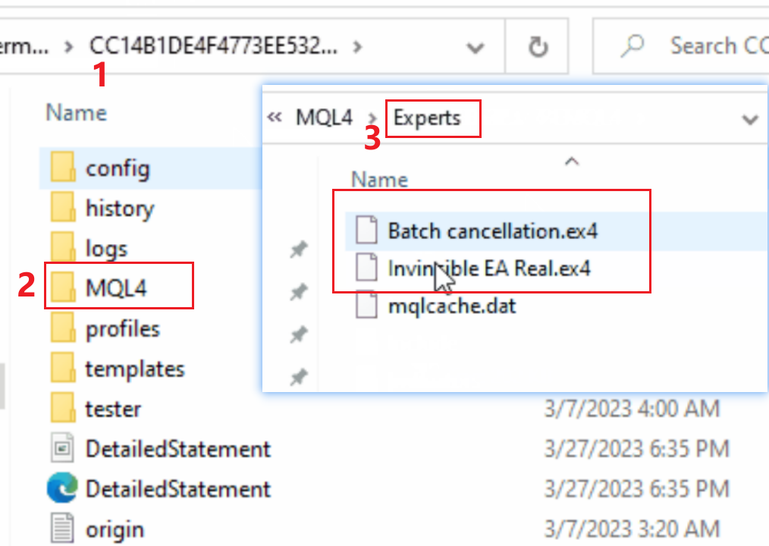

**And then hit Refresh**

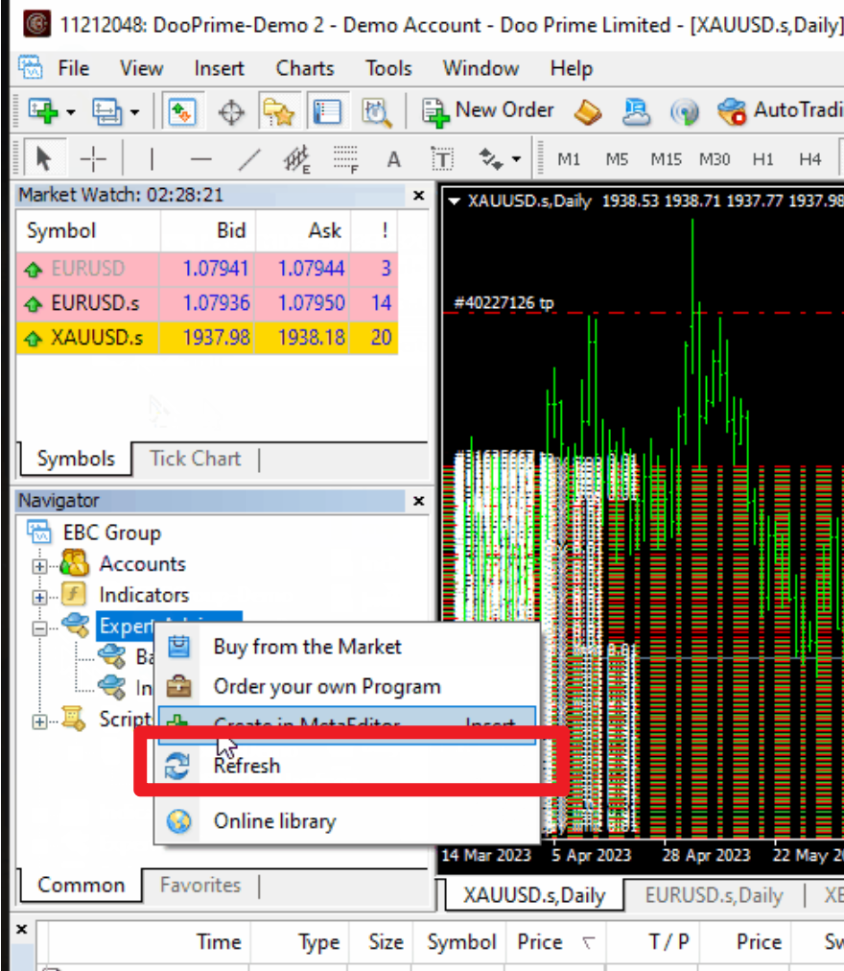

**Click to set the parameters**

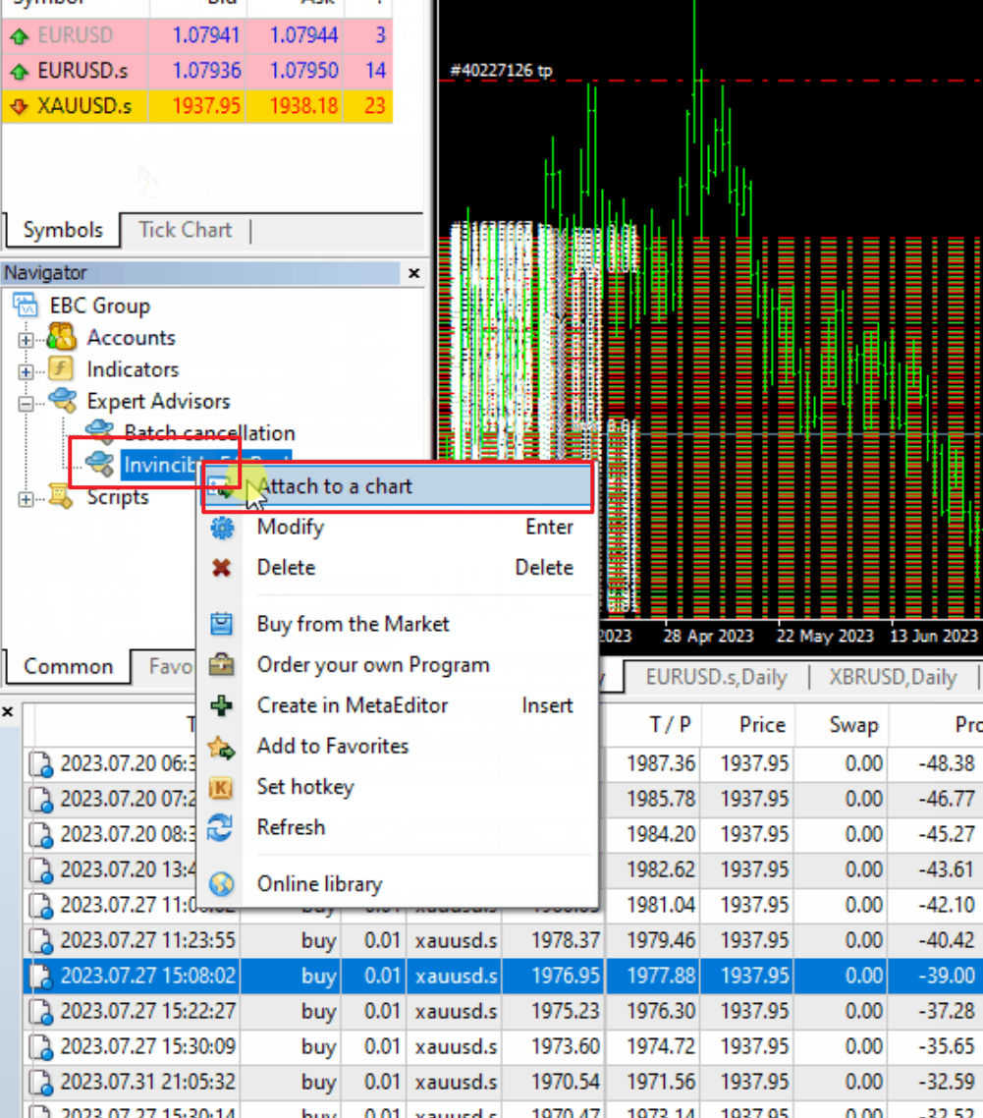

**You can set the following parameters.**

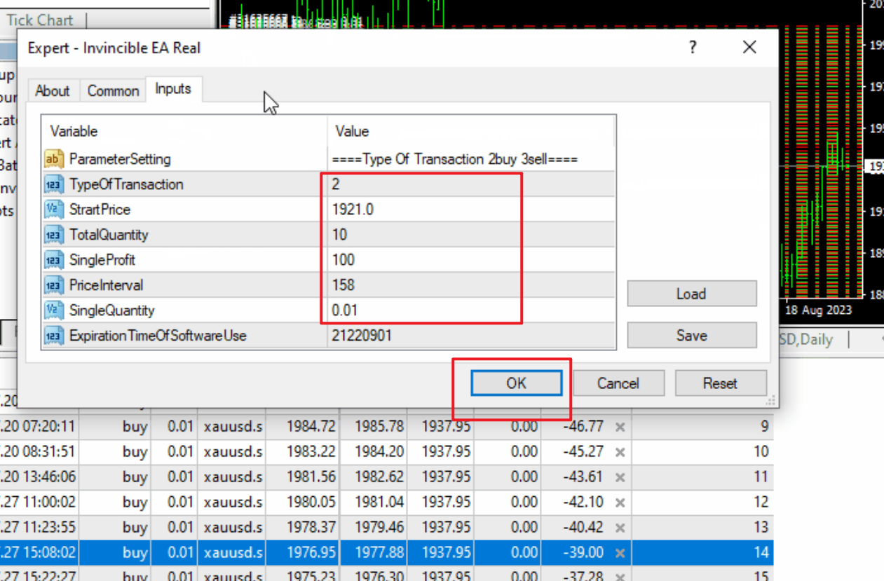

## If you want to buy a batch of orders, select 2 and add 5 parameter Settings to enable automatic trading

**Open AutoTrading**

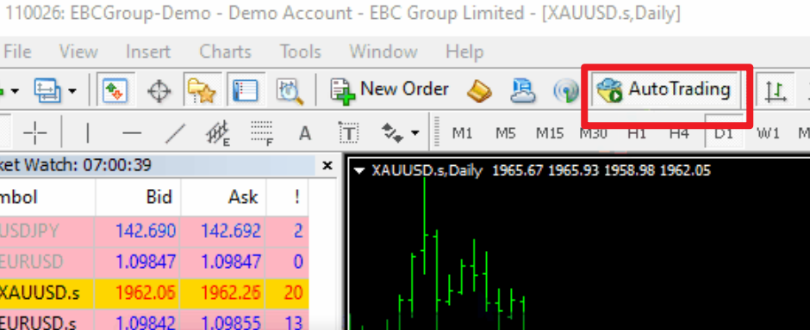

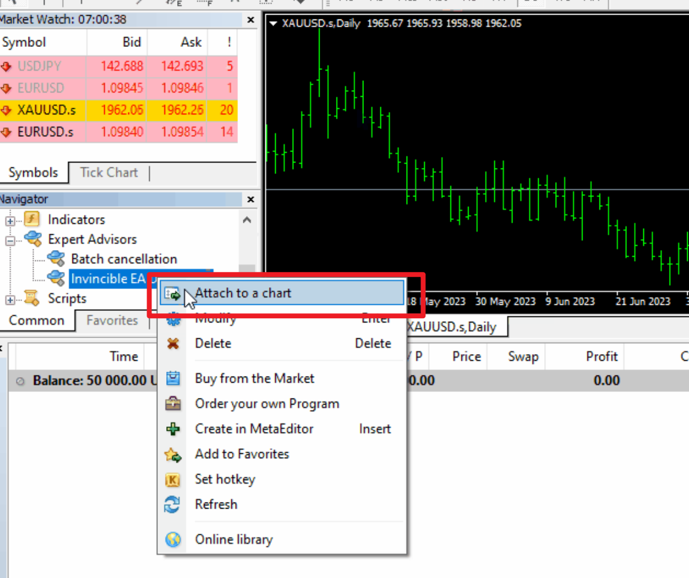

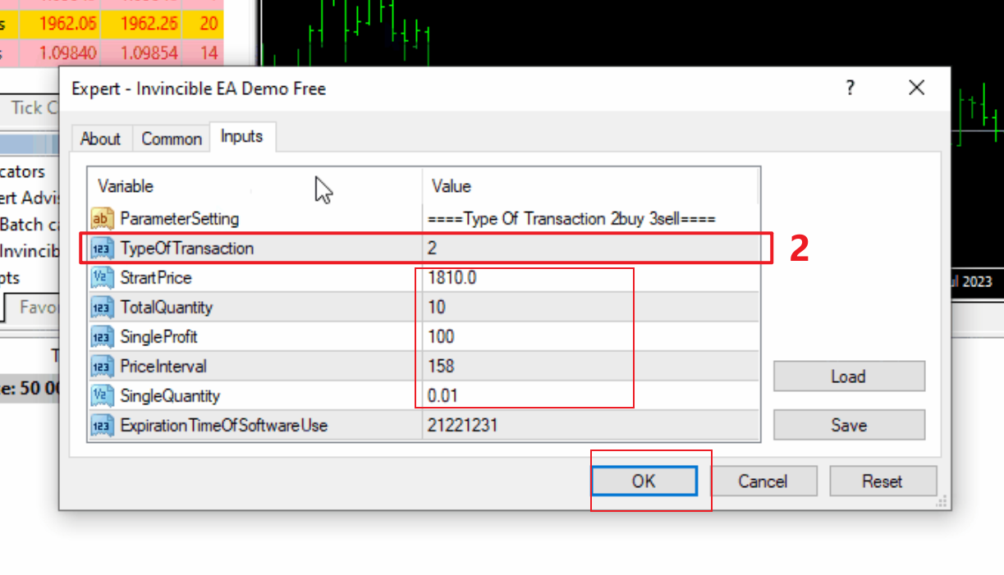

## If you want to sell a batch of orders, select 3 and add 5 parameter Settings to enable automatic trading

**Open AutoTrading**





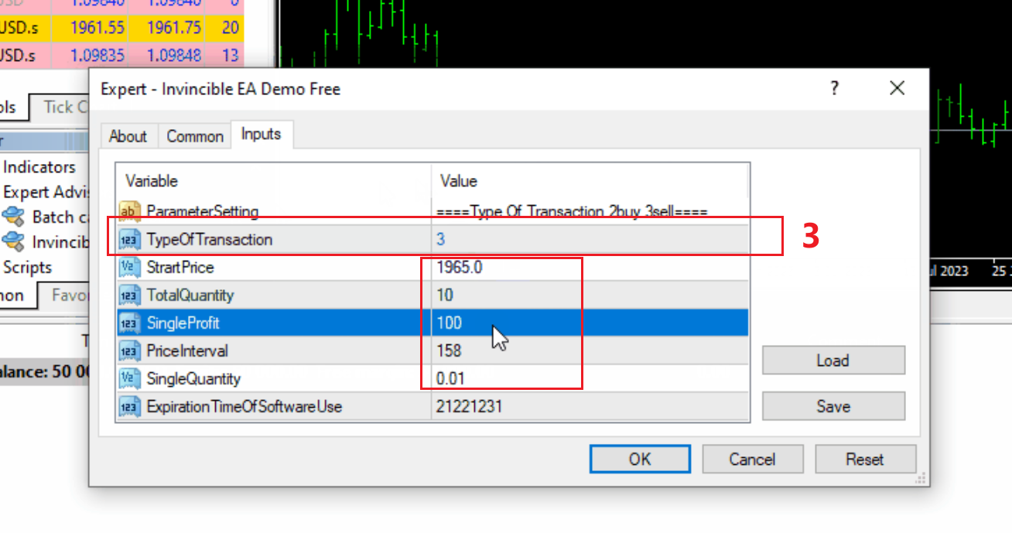

1. **If you want to cancel a batch of orders, select Batch Cancel EA.**

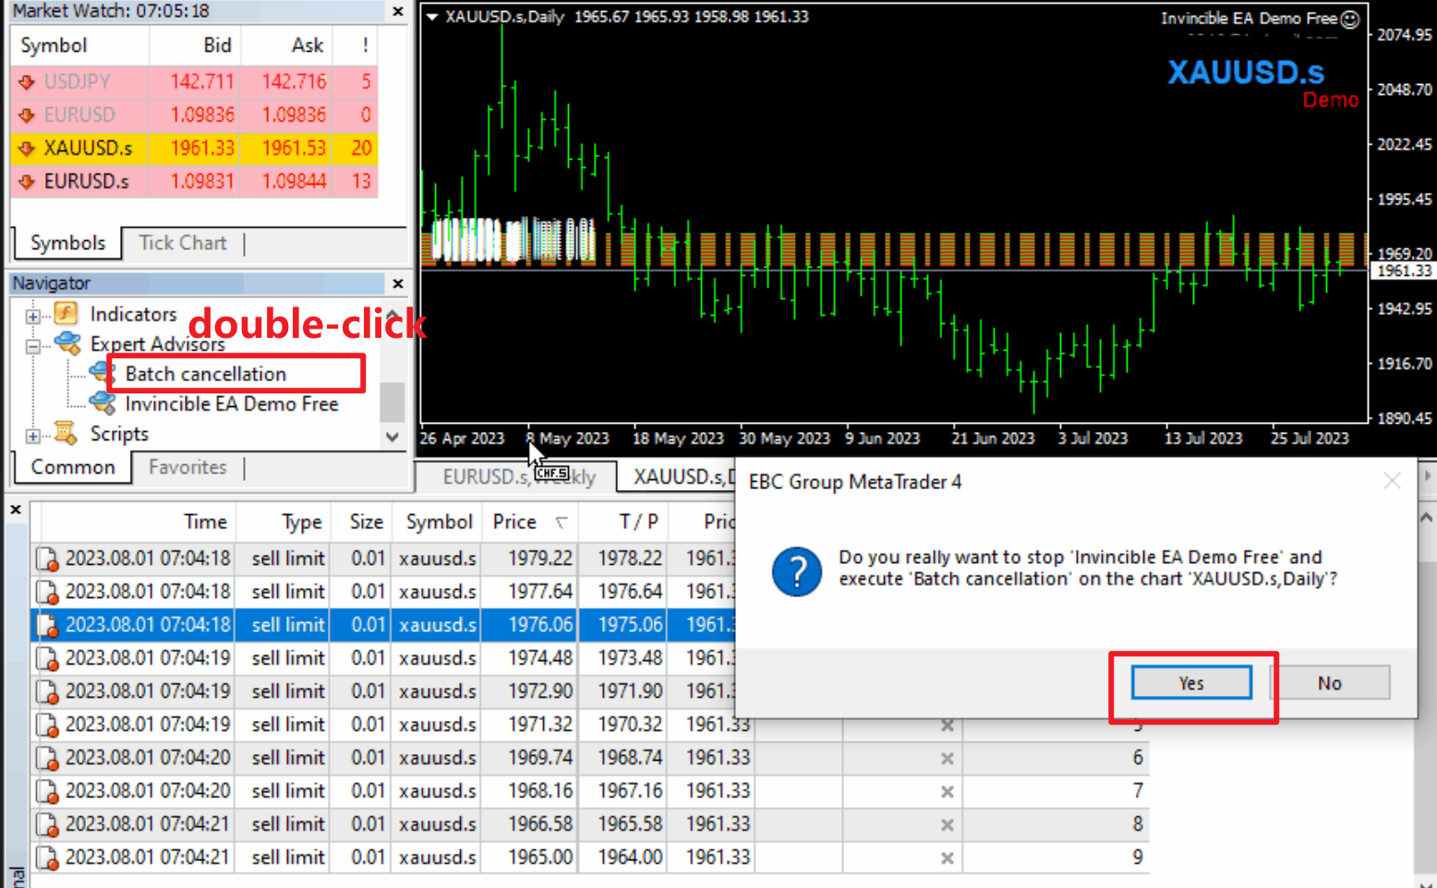

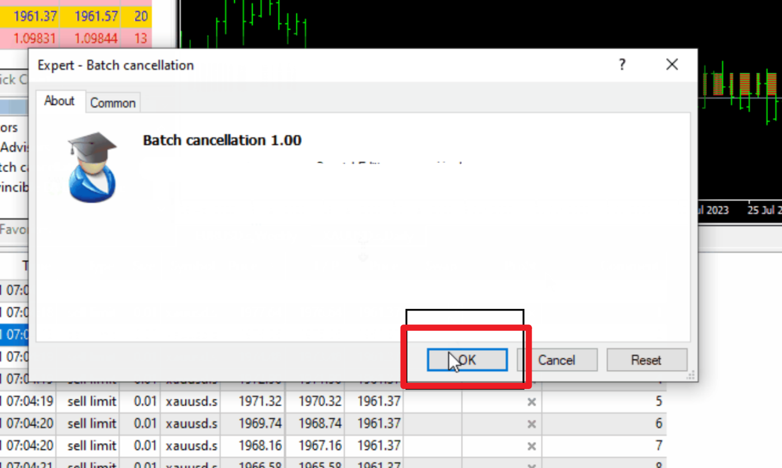

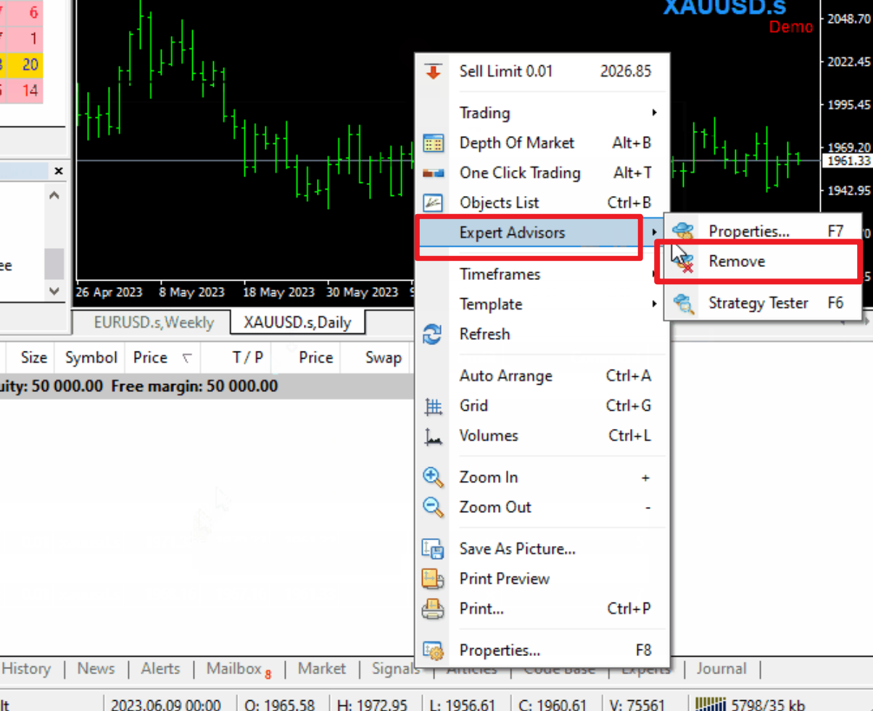

# Partial display



# trade category

## Gold/XAU

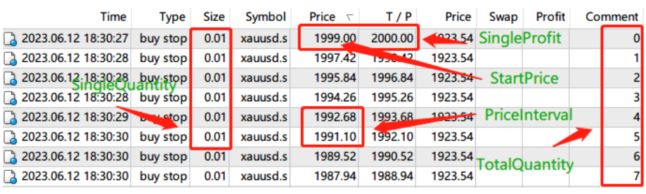

**Type Of Transaction :2 is Buy, 3 is Sell ✅ The significance of setting 5 parameters is shown in the figure.**

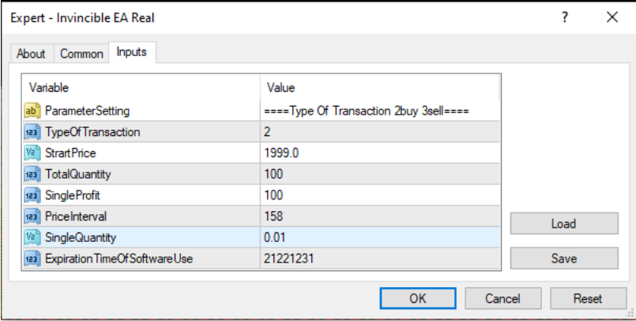

**The above parameter settings are suitable for Gold .**

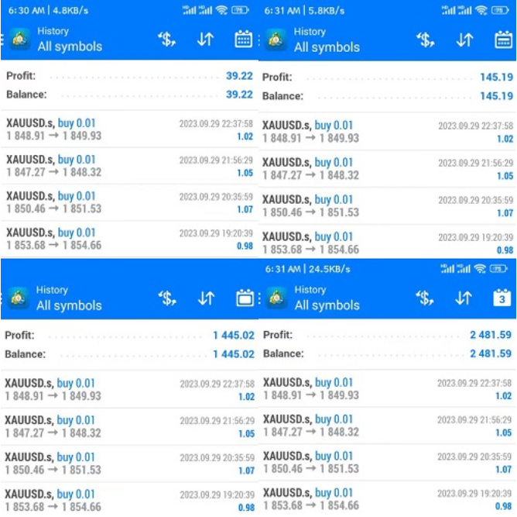

**Data statistics for the past day, week, month, and 3 months**

Account: 11212048

Server: DooPrime-Demo 2

Investor Password: hz123456

**After logging in, you can view each transaction data in detail and conduct further statistical analysis and research on your own.**

## EUR/GBP/JPY

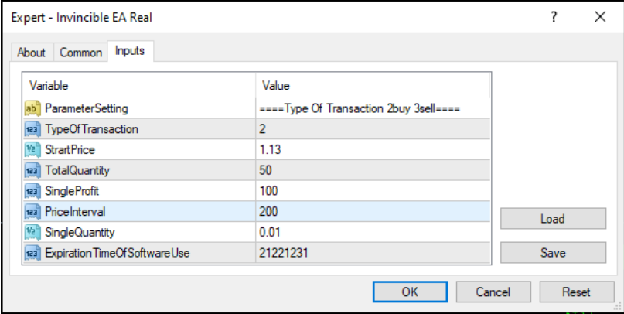

**The above parameter settings are suitable for EUR .**

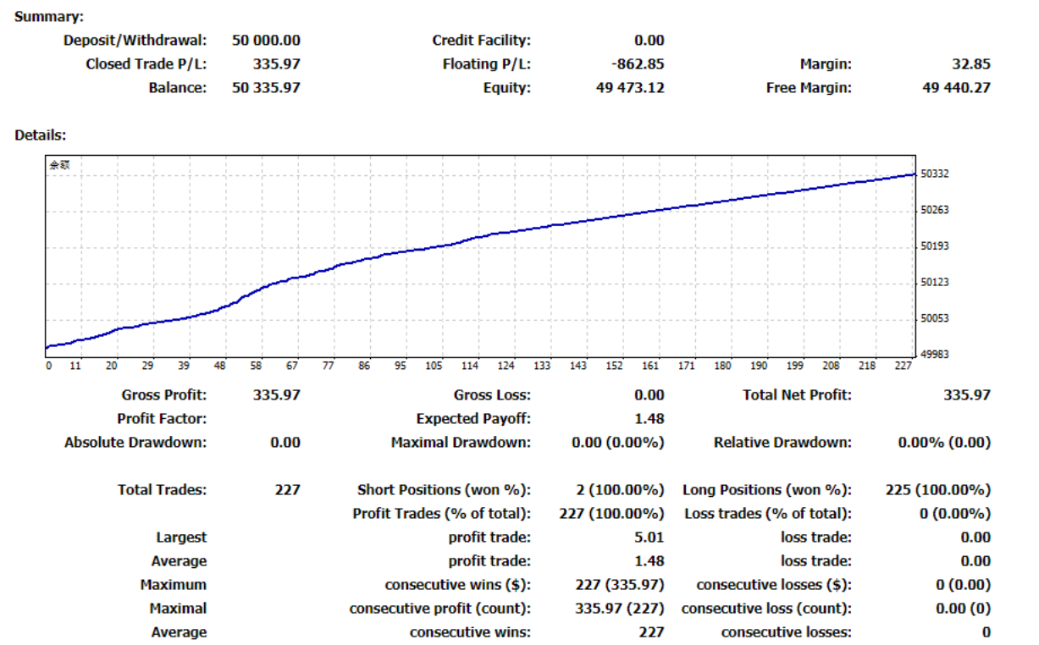

**Latest Data Statistics**

Account: 109490

Server: EBCGroup-Demo

Investor Password: hz123456

**After logging in, you can view each transaction data in detail and conduct further statistical analysis and research on your own.**

## Brent/WTI Oil

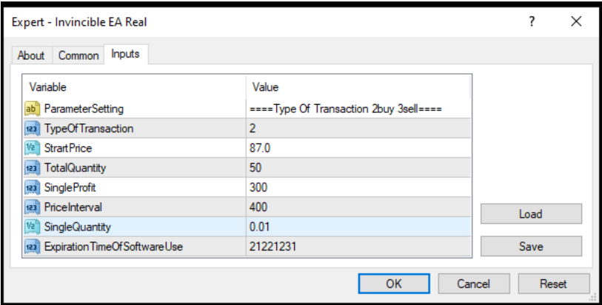

**The above parameter settings are suitable for Brent Oil .**

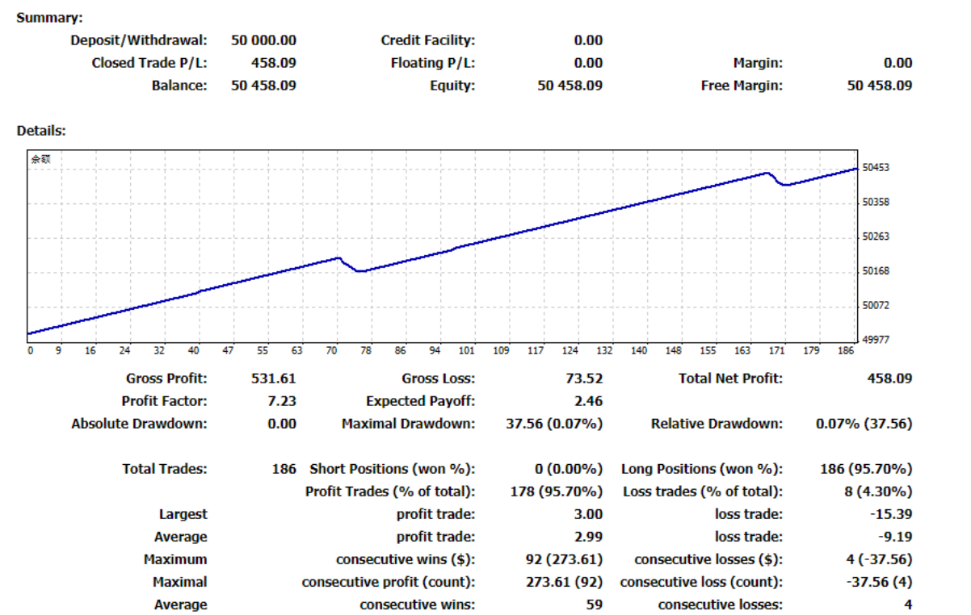

**Latest Data Statistics**

Account: 100219678

Server: AUSForex-Demo

Investor Password: hz123456

**After logging in, you can view each transaction data in detail and conduct further statistical analysis and research on your own.**

## BTC/ETH

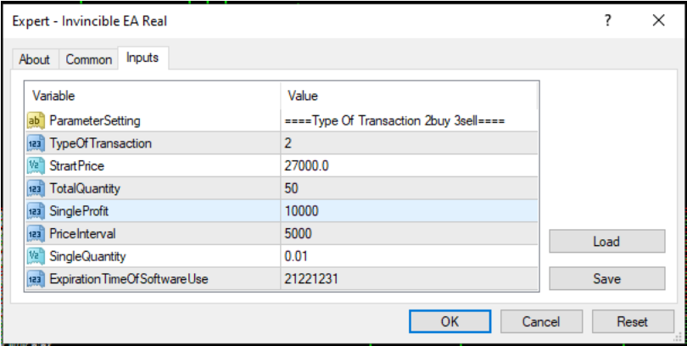

**The above parameter settings are suitable for BTC .**

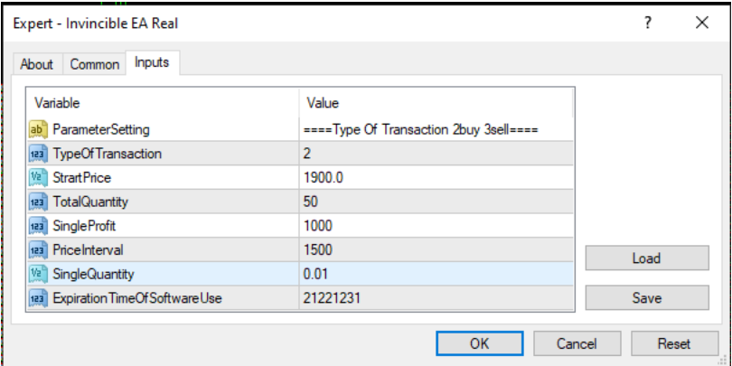

**The above parameter settings are suitable for ETH .**

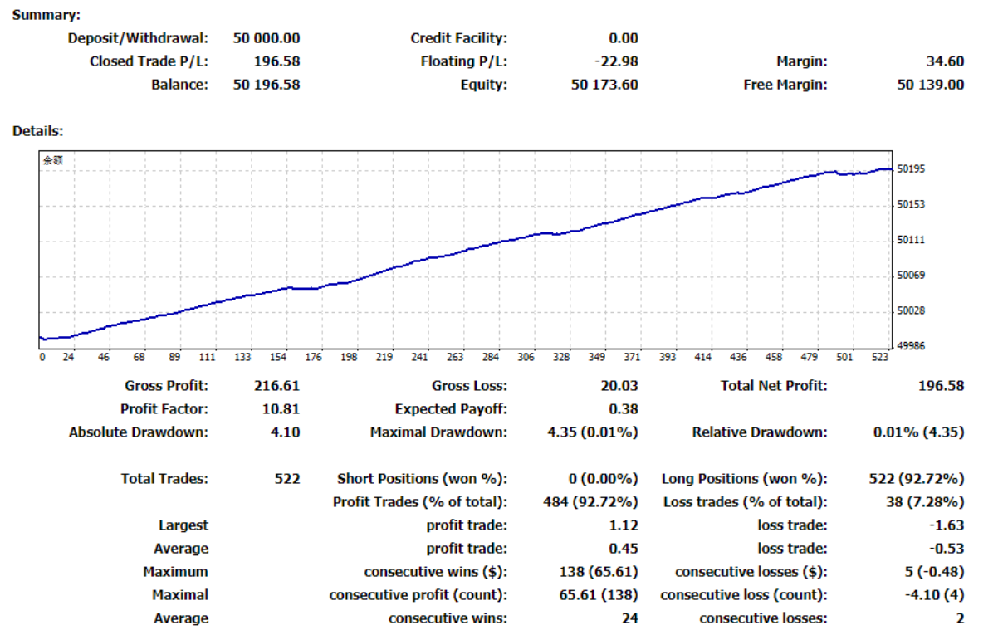

**Latest Data Statistics**

Account: 500873722

Server: RoboForex-Demo

Investor Password: hz123456

**After logging in, you can view each transaction data in detail and conduct further statistical analysis and research on your own.**